**Problems that need fixing**

**Data entry**

* The GROUP option is needed in the local version.
* We (researchers) should be able to change the settings (i.e. which groups should be available at data entry).

**Craving ratings**

**Rating questions need to be included at several stages of the task.**

|  |  |  |  |  |
| --- | --- | --- | --- | --- |
| **Phase** | **Group** | **Position** | **Rule** | **Question (s)** |
| 0 | Drug category | After shopping frequency question | When the drug group is selected (Cocaine or crack cocaine) | * If you were not here with us, which drug would you be using right now? |
| 0 | Alcohol | When alcohol group is selected | * How much do you want to have some alcohol right now? |
| 0 | Control | ---------- | -------- | ---------- |
| 1 | Drug | After the VAS question how much they would have liked to continue shopping. | Rule of the rating order:   1. Drug group selected (cocaine or crack). 2. Drugs indicated at the multiple-choice questions at phase 0 before phase 1. 3. If participant ALSO bought a drug that was not their drug of dependence and that they did not indicate this drug in the multiple-choice questions, then the drug they purchased should be rated as well. | 1. **Rating question based on group status:** How much do you want to use cocaine/crack right now? 2. **Rating based on participants’ purchases of drugs and alcohol.** Please tell us how much you would like to use it right now.   **If participant bought different types of alcohol, only one question will be asked:** Please tell us how much you would like to use it right now.  If participants did not purchase a drug that they indicated in phase 0 that they would use right now, we ask:   1. **Rating question based on choices participants made in phase 0 multiple-choice question** (which drug they would be using); How much do you want to use (name of the drug) right now?   NOTE: Each drug should only be rated ONCE, not several time although different rules may apply. |
| 1 | Alcohol | After the VAS question how much they would have liked to continue shopping. | 1. Alcohol group was selected. 2. Alcohol users bought drugs. | How much do you want to have some alcohol right now? (question based on group status)  Please tell us how much you would like to use (name of the drug) right now.  Example, if they selected hashish, they will be asked about cannabis.  Each drug they bought should be rated. |
| 1 | Control | After the question how much they would have liked to continue shopping. | 1. Controls bought alcohol. 2. Controls bought drugs. | How much do you want to have some alcohol right now? (question based on group status)  Please tell us how much you would like to use (name of the drug) right now.  Example, if they selected hashish, they will be asked about cannabis.  Each drug they bought should be rated. |
| 2 | Drug | After the question are you happy with the items that you successfully bid for | Ratings:   1. Drugs/alcohol according to purchases 2. Drugs according to group status. 3. Drugs according to multiple choice (phase 0) | Ratings:  Please tell us how much you would like to use (name of the drug) right now?  Please tell us how much you want to have some alcohol right now?  NOTE: Each drug should only be rated ONCE, not several time although different rules may apply. |
| 2 | Alcohol | 1. Alcohol group was selected. 2. Alcohol users bought drugs. | Please tell us how much you would like to use (name of the drug) right now?  Please tell us how much you want to have some alcohol right now? |
| 2 | Control | 1. Controls bought alcohol. 2. Controls bought drugs. | Please tell us how much you want to have alcohol right now?  Please tell us how much you would like to use (name of the drug) right now. |

**Phase 1**

Would it be possible to write 2-word categories in two lines rather than in one line:

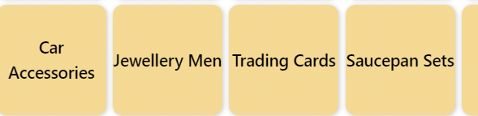

Like this (examples):

|  |  |  |
| --- | --- | --- |
| Jewellery  Men | Trading  Cards | Saucepan  Sets |

Two-word categories combined with & or 3-word categories to be displayed:

|  |  |  |  |  |  |  |
| --- | --- | --- | --- | --- | --- | --- |
| AirPods & Ear Buds | Gift Sets Men | Gifts Sets Women | Gifts  for Him | Arts  & Crafts | Tins & Jars | Packaging & Wrapping |

|  |  |  |  |  |
| --- | --- | --- | --- | --- |
| Lunch  Boxes  Adults | Lunch  Boxes  Kids | Outdoor Games  Adults | Outdoor Games  Kids |  |

* Category tiles: Opened categories should not come up again when participants scrolls down, before all items have been shown.
* Items within a category should not be repeated before all other items of that category have been shown.
* Once participants used up their budget of £1000:
  + “congratulations” slide & sound (they are told that they are the lucky customer, and all their purchases will be paid for).
  + From then onwards, the budget in the top left corner should show **Budget: unlimited** (see below);



* + the value of their purchases will still be recorded in the excel file (although participants don’t see them anymore).
* Clicking “Add to Trolley” needs a **sound** (see attachment);  
  Clicking “Back” should remain as it is, no sound.

End of phase 1:

All participants should be asked at several questions at the end of part 1.

Depending on their drug use and drug/alcohol purchases they will be introduced with the following slide:

|  |  |
| --- | --- |
| Participants in drug user category  Participants who purchased drugs/alcohol | All other participants |
|  |  |

The questions will be as follows (see slides):

1. Are you happy with your purchases?
2. Would you have liked to continue shopping?
3. Did you only shop for items you like?
4. Did you only shop for items other people like?
5. Did you only shop for expensive items?

All ratings should be: not at all -------------------------------------- very much

If participants bought drugs/alcohol, then participants will be asked to rate how much they would like to use each drug they purchased (or their drug of dependence) / alcohol.

If they bought alcohol (no matter what type of alcohol), they will be asked one general question about alcohol (not about the specific type of alcohol).

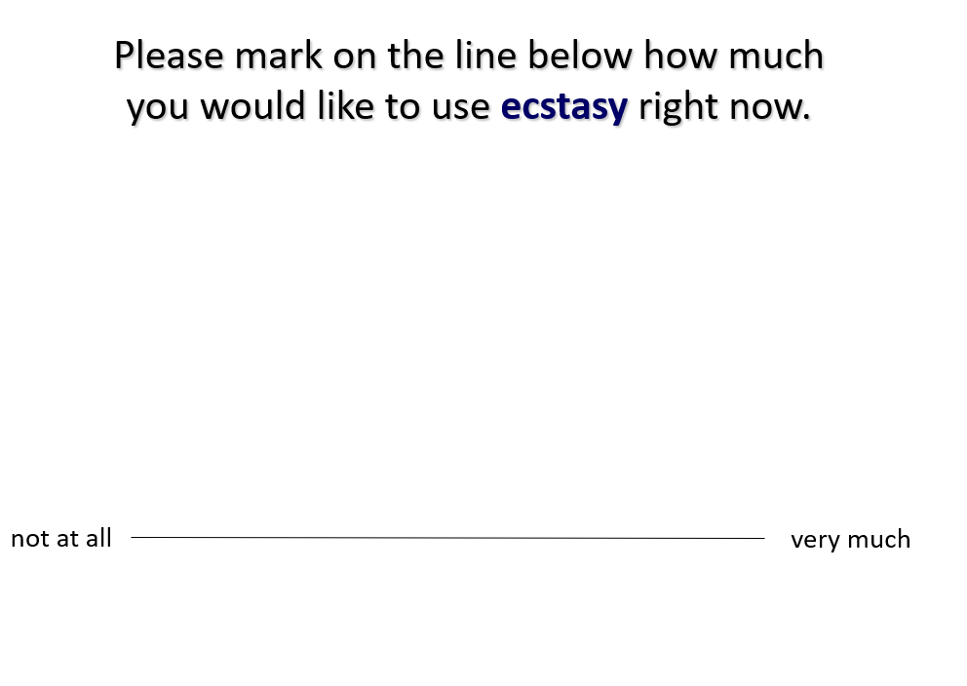

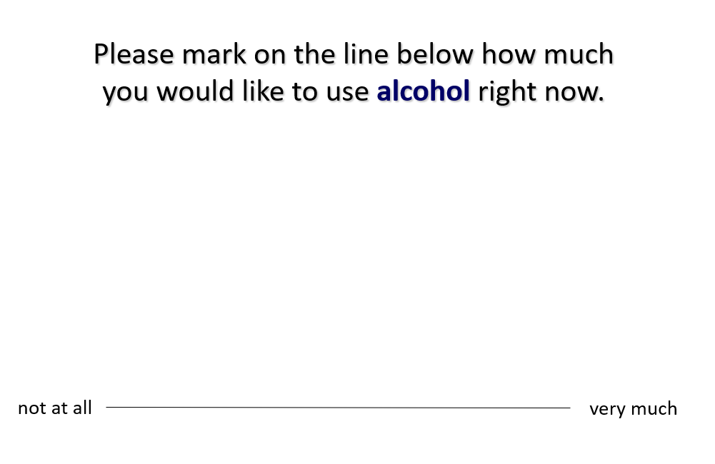

Only if participants said at phase 0 that they would like to use a particular drug right now, but did not purchase this drug, they should be asked to rate it as well.

* No download after phase 1.

**Phase 2**

* Start slide of phase 2 is missing!

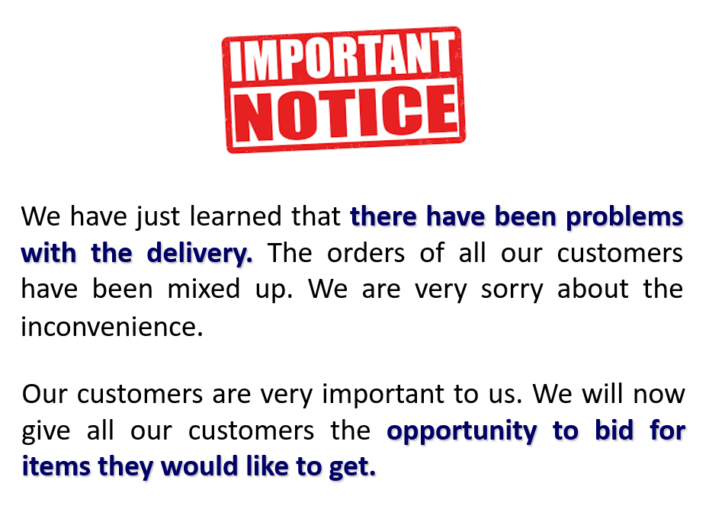

* Problem with bulb tick box.



VERY IMPORTANT: **The rules about item presentation in phase 2:**

|  |  |
| --- | --- |
| **Other customers’ trolleys** | **Participant’s trolley** |
| * Flagged categories should NEVER be presented, which are drugs (and related), alcohol (and related), Sex, Gaming and Electronics (see list) * Categories that participants had looked at (irrespective of whether they selected items or not) should NEVER appear. * The number of items in other customers’ trolleys should NOT match the number of items in the participant’s trolley. Other customers can have more items in their trolleys than the participant. | * ONLY items they purchased (put in trolley). * NOT items they removed from the trolley. * NOT items that they have looked at (but did not purchase) * Participants’ items should only repeat when all of their items had been presented. |

* **Not all blocks have free rewards!!!!! Please correct the contingencies as follows:** 
  + Block 1: Non-degraded (no free rewards)
  + Block 2: Non-degraded (no free rewards)
  + Block 3: Non-degraded (no free rewards)
  + Block 4: Partial degradation (free rewards 30% of the time)
  + Block 5: Full degradation (free rewards 60% of the time)
  + Block 6: Non-degraded (no free rewards)
  + Block 7: Partial degradation (free rewards 30% of the time)
  + Block 8: Full degradation (free rewards 60% of the time)
* **When the finger is placed on the keyboard:**
  + **responses should not count**
  + **nasty sound should be played**

**This is the question that should be asked in between blocks.**

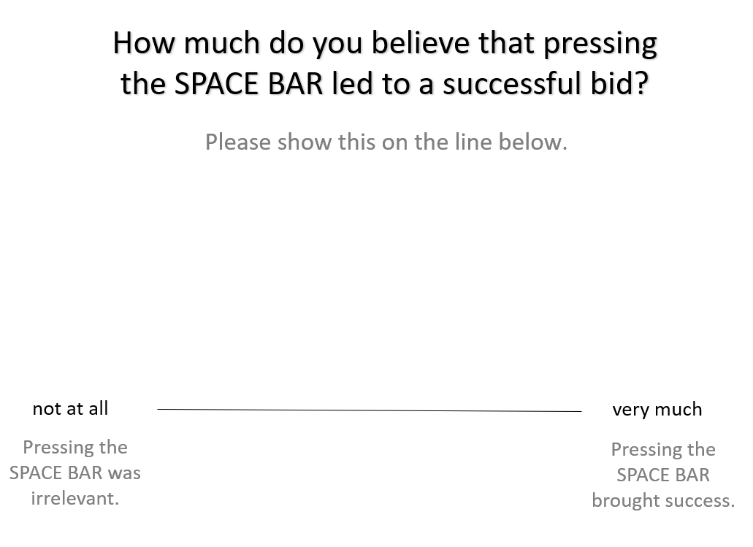

Please keep the grey text below “not at all” and “very much”.

* The progress bar has not yet been implemented:

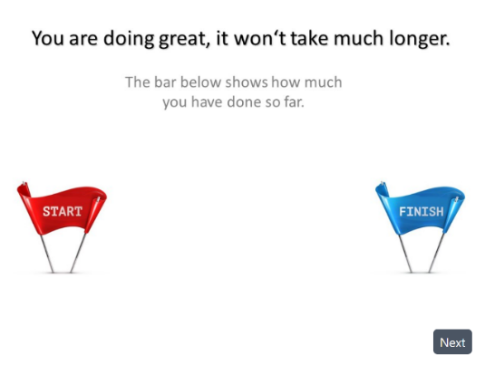

* Well done slide should give feedback of the

|  |  |
| --- | --- |
|  | * The successful responses should be shown on the slide (i.e. responses when participants received the item and the free bees). * A random number between 50 and 100 indicates the items that participants will actually receive. |

* Then participants should be asked to rate all the drugs they purchased,
  + If they also purchased alcohol, they will be asked to rate alcohol.
  + If not already rated, the drugs they indicated to use in phase 0
  + If not already rated, the drug that defines their category, then they should rate it now.
* No download at the end of phase 2.

**Phase 3:**

* The question about the shopping list is missing:

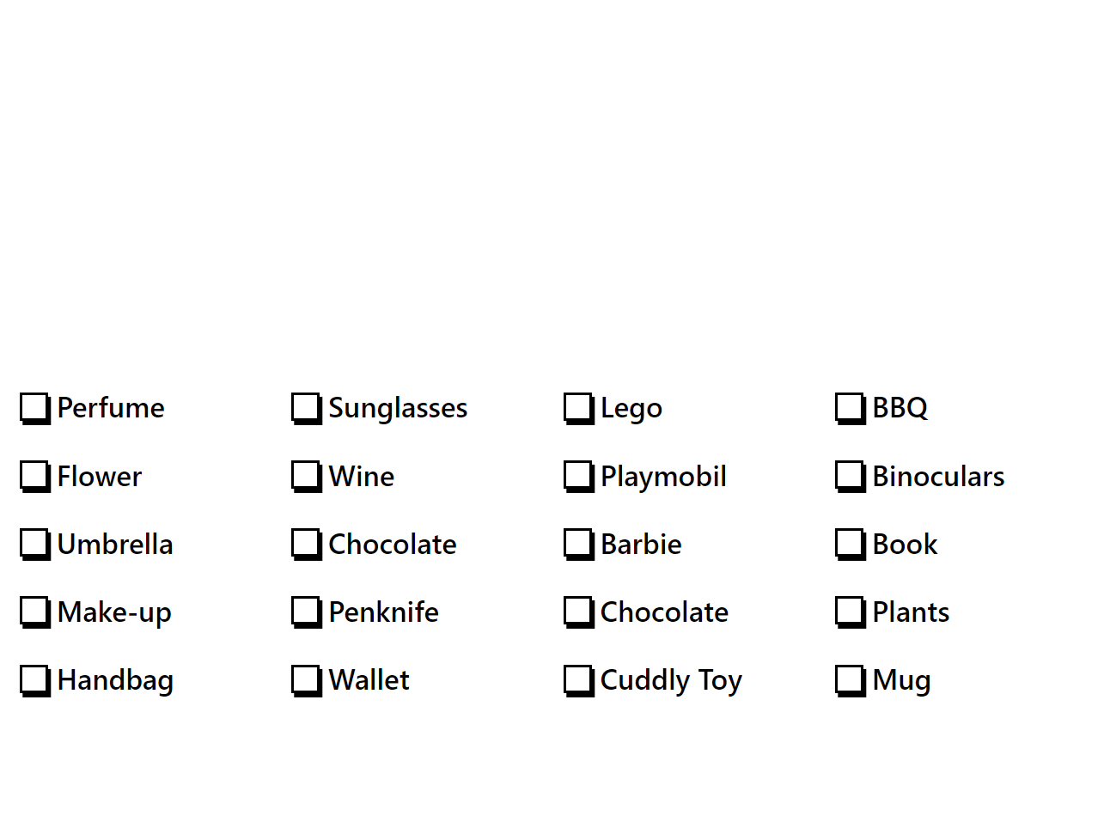

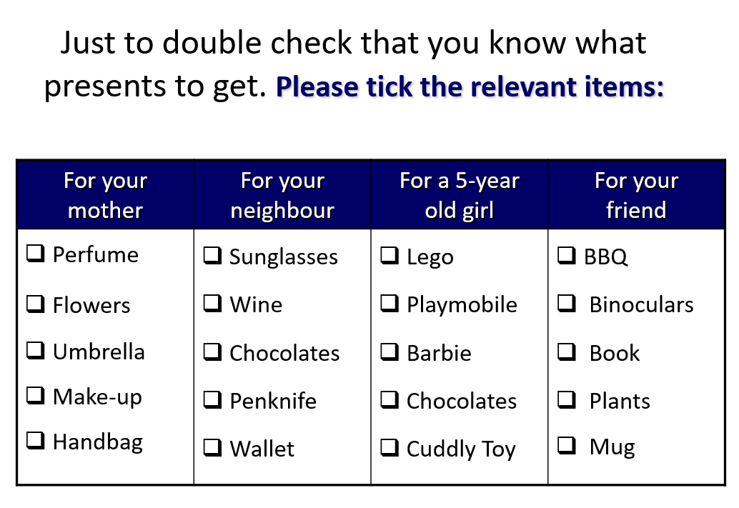

* Please double the presentation time for the penultimate side.

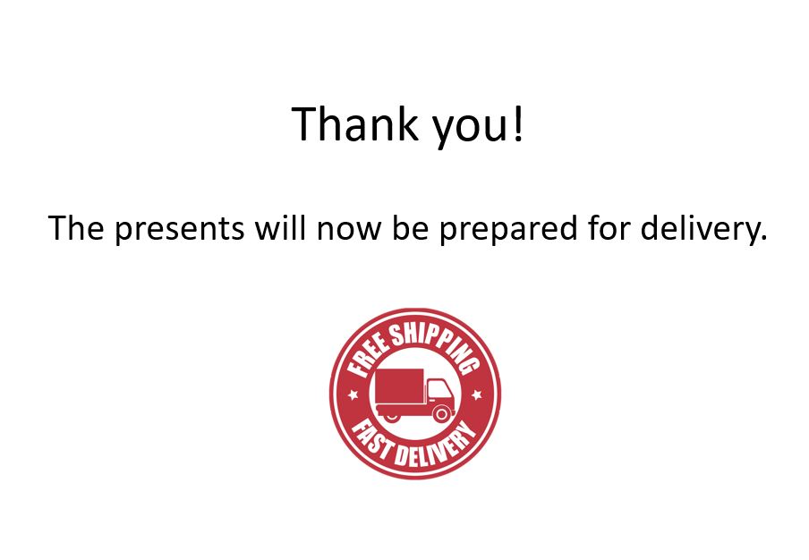

**************

* **Almost all slides have been revised and need to be replaced.**
* **All categories have to be replaced.**
* **Aggregate variables need to be calculated.**
* Descriptive information need to be provided (total number of items per category, average price, minimum/maximum price)

**If possible:**

Could you please disable ALL previous links to test part 1.

Could you please send us a new link for part 1 because we would like continue piloting.